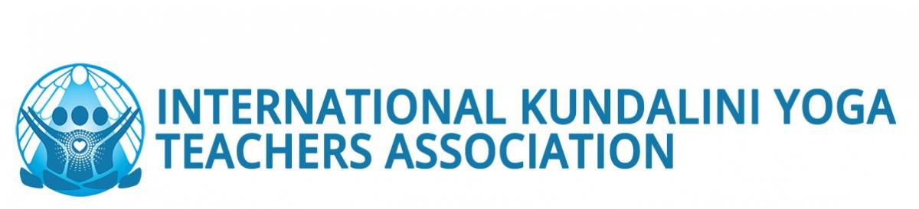
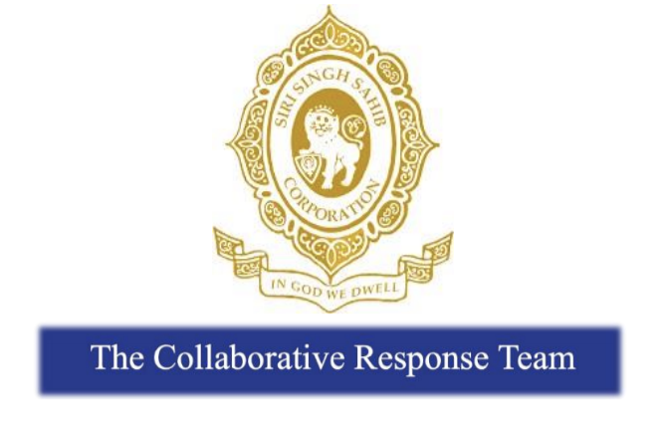
March 9, 2020
Sat Nam Dear Members of our 3HO, Sikh Dharma and KRI Community,
The dedicated email address for communicating with An Olive Branch is now active. This will be a fully confidential method of communication. You can reach them at yb.investigation@an-olive-branch.org until April 30, 2020.
We take the allegations that have been brought forth regarding Yogi Bhajan very seriously and encourage anyone with relevant experiences or information to speak with An Olive Branch. Interviews are private and confidential between the individual and the investigator.
An Olive Branch is conducting an independent third-party investigation. The sole purpose of this investigation is to seek the truth, and the investigation will not be influenced in any way by the CRT or the SSSC.
Due to the sensitive nature of its work, An Olive Branch is unable to share their specific work experience publicly. We realize that this level of confidentiality has prompted questions within the community about the organization’s capability to conduct a thorough investigation. During the course of our due diligence, we found An Olive Branch fully met the critical requirements to be entrusted with completing this important task, including:
- Extensive experience in investigating claims of sexual misconduct with thoroughness and compassion.
- Significant experience conducting investigations for and understanding the issues unique to spiritual or religious-based organizations.
- Demonstrated ability to relate well to those reporting harm as well as others providing information.
- Ability to instill confidence that all individuals in the matter will be treated with sensitivity and care.
As members of a spiritual community, we place a high value on righteous action and truthful living. We are committed to upholding these principles, in practice and policy, at all levels of our organizations and to strengthen our organization to meet these commitments. Our goal is to seek the truth and move toward healing. We open our hearts and prayers for justice and healing of all people.
Sat Nam,
Collaborative Response Team
ssscresponseteam.org
